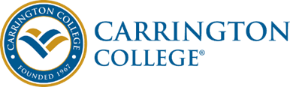

JOB DESCRIPTION

Job Title: Sterilization Tech
Department: Academic Affairs
Reports To: Program Director/Campus Director
Classification: Non-Exempt/Full-Time

Summary: Carrington College faculty are engaged, accountable, innovative, change ready professionals dedicated to their students and to the College Mission. Carrington College faculty are proficient in all learning modalities applicable to the program in which they teach.

Essential Duties and Responsibilities:
The Sterilization Technician provides support and assistance to the public, students, and staff by providing sterilization and maintenance support to Dental Hygiene Program and by performing a wide variety of technical, clerical, and maintenance duties.
- Maintains a clean and orderly work area.
- Cleans, bags, and sterilizes instruments.
- Washes, dries, and puts away lab coats.
- Maintains and repairs equipment.
- Maintains inventory.
- Orders supplies and instruments for the students.
- Keeps abreast of up-to-date OSHA requirements and MSDS forms.
- Assists the Dental Hygiene Program Director as needed.
- Completes other duties as assigned.
Experience working effectively in an environment with constant interruptions and a high volume of interactions. Experience communicating effectively verbal and in writing. Possess excellent organizational and multiple tasking skills with the ability to coordinate many diverse activities. Possesses extensive experience with computer systems including Word, Excel, PowerPoint, the Internet, e-mail and general office equipment.
The ability to type 45 wpm and create graphs, tables, charts and checklists is desired. We are proud to be an EEO employer M/F/D/V. We maintain a drug-free workplace and perform pre-employment substance abuse testing. Thank you for applying for this outstanding opportunity today.

