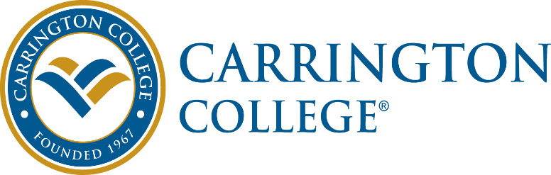

Job Description
Summary: Carrington College faculty are engaged, accountable, innovative, change ready professionals dedicated to their students and to the College Mission. Carrington College faculty are proficient in all learning modalities applicable to the program in which they teach.
Essential Duties and Responsibilities:
- Delivers course material in accordance with college curriculum.
- Fulfils administrative requirements for each course including attendance, Student Learning Outcome (SLO) assessment data, posting grades in a timely manner and outreach to students.
- Utilizes student achievement and learning outcome data to develop program improvement strategies and participates in formal processes of program improvement, such as program review, program assessment, program design, and program evaluation.
- Demonstrates willingness to develop proficiency in all applicable learning methodologies through continuous improvement.
- Ensures the program consistently adheres to applicable institutional, governmental and accreditation standards.
- Participates as subject matter expert in appropriate Industry Advisory Councils, Faculty Council, Assessment Council, and industry associations, etc.
- Builds networks within the local industry for programmatic support.
- Engages in activities focused on student service, such as new student orientation, student clubs, student appreciation event, outreach, enrollment and career services events.
- Provides proactive student advisement and tutoring.
- Involved in all departmental and programmatic activities.
- Mentors new faculty members and participates in the Academy of Master Instruction mentoring program.
- Aids with ensuring that program equipment and books adhere to the Standard Equipment List and the Standard Book List.
- Assists in ensuring program meets College set standards for the program, including persistence, retention, graduation, 3rd party examinations and placement.
- Maintains high standards of professionalism and accountability and models positive behaviors for our students.
- Works collaboratively with interdepartmental campus colleagues to ensure program students receive learner support to achieve success.
- Is on time and present each day as required and conducts class for full class periods.
- Acts as substitute instructor for academic colleagues as required.
- Completes other duties as assigned.
Supervisory Responsibilities: Faculty supervise student conduct in the classroom, on the campus, and on field trips and school related functions.
Competencies: To perform the job successfully, an individual should demonstrate the following competencies:
Core Competencies:
Integrity: Acts in a way that demonstrates personal integrity; serves as a positive example of why others should trust the motives of the organization; views self as a reflection of the organization by following through on commitments and accepting ownership of mistakes; leaves others with the clear impression that integrity is a core organization value.
Professionalism: Approaches others in a tactful manner; reacts well under pressure; treats others with respect and consideration regardless of their status or position; accepts responsibility for own actions; follows through on commitments.
Adaptability: Adapts to changes in the work environment; manages competing demands; changes approach or method to best fit the situation; able to deal with frequent change, delays, or unexpected events.
Organization Support: Follows policies and procedures; completes projects and tasks correctly and on time; supports organizations goals and values.
Communication: Communicates effectively and appropriately; uses good judgment as to what to communicate to whom as well as the best way to get that accomplished; speaks in clear and credible manner, selecting the right tone for the situation and audience; listens to others and allows them to make their point.
Position Competencies:
Instructional Skills – Comes across as confident and well-prepared when providing instruction in small and large groups; effectively utilizes instructional resources to meet the variety of student learning needs; applies engagement and assessment techniques.
Content-Specific Knowledge - Understands the fundamentals, skills, methods and procedures within their area of expertise and instructional practice.
Dependability - Makes and fulfills commitments; has established a pattern of working independently, meeting reasonable deadlines, and accepting responsibility for actions; willingly makes promises and fully intends to keep them; arrives to work on time and ready to contribute and conducts class for full class times; shows up for meetings well prepared and engaged. Student Achievement Focus - Personally demonstrates that students and employers are a high priority; identifies student needs and expectations and responds to them in a timely and effective manner; anticipates and prevents delays or other things that can adversely affect the student; keeps student informed about progress.
Qualifications: To perform this job successfully, an individual must be able to perform each essential duties and responsibilities satisfactorily. The requirements listed below are representative of some of the knowledge, skill and/or ability required. Reasonable accommodations may be made to enable individuals with disabilities to perform the essential functions.
Education and/or Experience
DVM or VMD; Minimum of 3 years field experience.
Language Skills
Ability to read, analyze, and interpret materials related to area of expertise; ability to respond to common inquiries or complaints from students, employees and members of the business community; ability to effectively present information to students, employees, and the business community.
Mathematical Skills
Ability to calculate figures and amounts such as discounts, interest, commissions, proportions, percentages, area, circumference, and volume; ability to apply concepts of basic algebra and geometry.
Computer Skills
To perform this job successfully, an individual should have knowledge of Microsoft Office Word, Excel, Access, Outlook and all software programs related to courses to be taught.
Certificates, Licenses, Registrations
Faculty must have required certificates, licenses and registrations required for the course(s) they are to teach.
Physical Demands: The physical demands described here are representative of those that must be met by an employee to successfully perform the essential functions of this job. Reasonable accommodations may be made to enable individuals with disabilities to perform the essential functions.
While performing the duties of this job, the employee is regularly required to stand; use hands to finger, handle, or feel; reach with hands and arms; talk; hear and speak. The employee is frequently required to walk; sit and stoop, kneel, crouch, or crawl. The employee is occasionally required to climb or balance. The employee must regularly lift and/or move up to 10 pounds, frequently lift and/or move up to 25 pounds and occasionally lift and/or move up to 50 pounds.
Work Environment: The work environment characteristics described here are representative of those an employee encounters while performing the essential functions of this job. Reasonable accommodations may be made to enable individuals with disabilities to perform the essential functions.
In some and/or all vocational classrooms, the employee is frequently exposed to moving mechanical parts. The employee is occasionally exposed to fumes or airborne particles and toxic or caustic chemicals. The noise level in the work environment is usually moderate.

